2403A51001

S.SWADHA REDDY

SET-B

TASK-01

Create a Python function that converts an amount from one currency to another using exchange rates stored in a dictionary. Use GitHub Copilot along with VS Code. Use Few shot prompting.

PROMPT: generate a python code to convert one currency to another using exchange rates stored in the dictionary and provide an option to give input

#convert_currency(100, 'USD', 'EUR', exchange_rates) -> 92.0

# convert_currency(200, 'GBP', 'JPY', exchange_rates) -> 36846.1538

# convert_currency(50, 'EUR', 'USD', exchange_rates) -> 54.3478

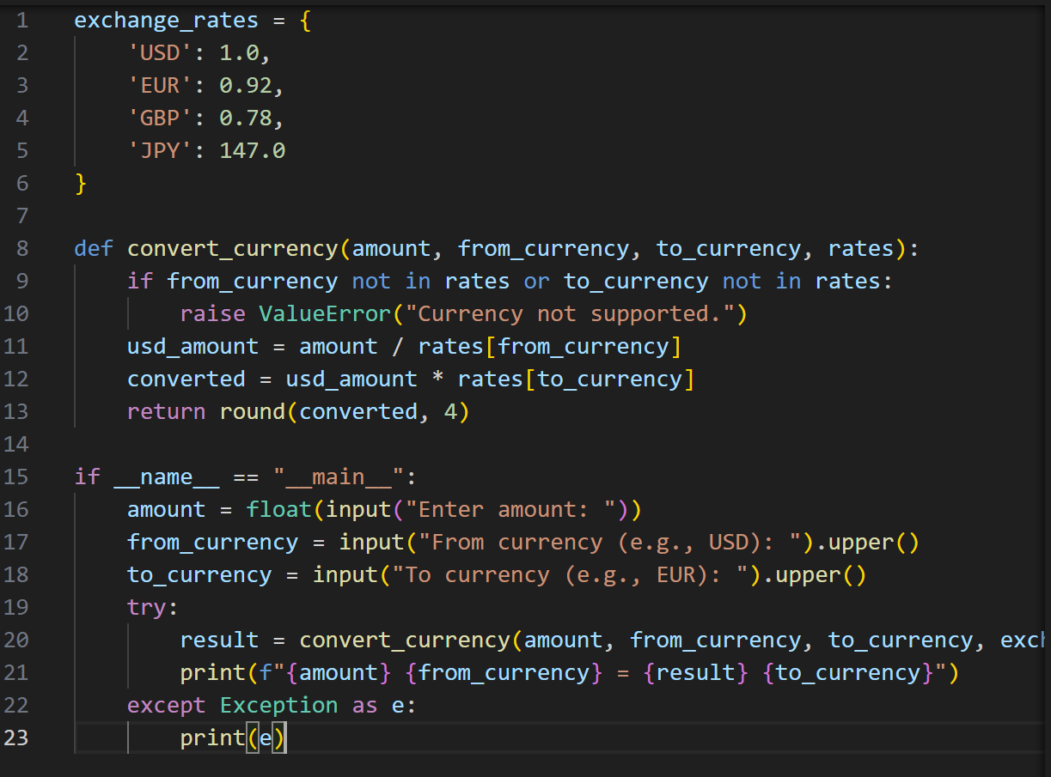

TASK-02

Write a Python program to extract all email addresses from a block of text using regular expressions. GitHub Copilot along with VS Code. Use zero shot prompting.

PROMPT: generate a Python code to extract all email addresses from a block of text using regular

expressions.provide an option to give input

# extract_emails("Contact us at sru@gmail.com or support@sru.org for help.")

# Output: ['sru@gmail.com', 'support@sru.org']

TASK-03

Given a list of movies with their genres, Write a Python function that recommends movies based on a user’s preferred genre. Use the Cursor AI tool. Use few shot prompting.

PROMPT:

generate a Python code to suggest moviesbased on a user’s preferred genre. provide an option to give input. provide few shot prompting example

# Few shot prompting examples:

# movies = [

# {'title': 'gita govindam', 'genre': 'romance'},

# {'title': 'Srinivasa kalyanam', 'genre': 'family'},

# {'title': 'shathamanambavathi', 'genre': 'family'},

# {'title': 'anabelle', 'genre': 'horror'}

# ]

# recommend_movies(movies, 'horror') -> ['anabelle']

# recommend_movies(movies, 'Romance') -> ['gita govindam']

# recommend_movies(movies, 'family') -> ['Srinivasa kalyanam','shathamanambavathi']

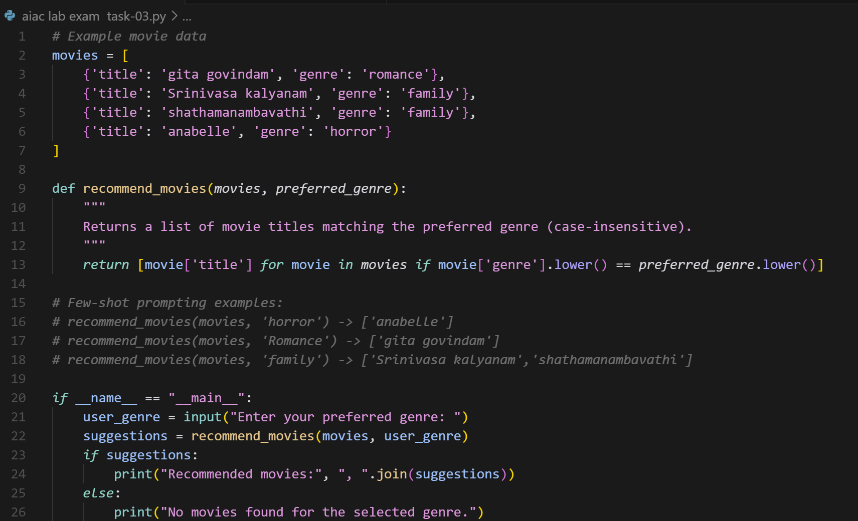

TASK-04

Write Python code that reads a CSV file containing student names and marks in 3 subjects. Calculate the total and average marks for each student. Use the Cursor AI tool.

PROMPT: generate a python code that reads a CSV file containing student names and marks in 3 subjects.Calculate the total and average marks for each student.provide an option to give input

